**Experiment No. __1__**

**Date of performance:** 17/08/22

**Date of Submission:** 17/08/22

**SAP Id: 500091584**

**Roll No.: R2142210822**

**Name of the Student: Ujjwal Kumar Gupta**

1. **Title: Package**
2. **Objective: Package**
3. **List of lab activities:**
4. Write a Java program to implement the concept of importing classes from user defined package andcreated packages.

2) Write a program to make a package Balance. This has an Account class with Display_Balancemethod. Import Balance package in another program to access Display_Balance method ofAccount class.

1. **Algorithm/Flowchart and Code followed by Output screenshot (2samples for each program):**

**package My_Cal_Pkg;**

**public class Calculator {**

**public int addition(int x, int y) {**

**return x+y;**

**}**

**public int Subtraction(int x, int y) {**

**return x-y;**

**}**

**public int Multiplication(int x, int y) {**

**return x*y;**

**}**

**public int Division(int x, int y) {**

**return x/y;**

**}**

**}**

**package My_Cal_Pkg;**

**import java.util.*;**

**public class Main_Calculator {**

**public static void main(String args[]) {**

**Scanner sc= new Scanner(System.in);**

**Calculator cal=new Calculator();**

**System.out.print("Enter first number: ");**

**int a=sc.nextInt();**

**System.out.print("Enter first number: ");**

**int b=sc.nextInt();**

**int sum=cal.addition(a, b);**

**System.out.println("Sum of numbers is "+sum);**

**int sub=cal.Subtraction(a, b);**

**System.out.println("Subtraction of numbers is "+sub);**

**int mul=cal.Multiplication(a, b);**

**System.out.println("Multilpication of numbers is "+mul);**

**int div=cal.Division(a, b);**

**System.out.println("Division of numbers is "+div);**

**sc.close();**

**}**

**}**

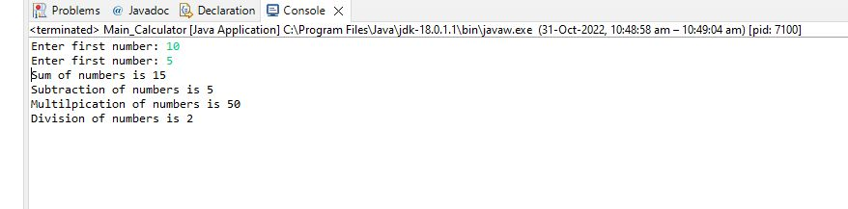

1. **Brief notes about all the concepts related to the lab experiment**

A java package is a group of similar types of classes, interfaces and sub-packages.

There are three ways to access the package from outside the package.

1. import package.*;
2. import package.classname;
3. fully qualified name.